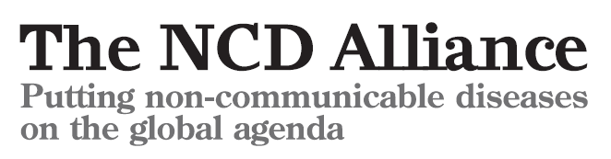
First global target on non-communicable diseases demands a reduction in preventable deaths by 25% by 2025
NGOs applaud government leadership on non-communicable disease death reduction
Geneva, 25 May 2012: After an intense week of lobbying by NGOs during the 65th World Health Assembly, governments are poised to agree to a historic target to reduce premature deaths from non-communicable diseases (NCDs - including cardiovascular diseases, diabetes, cancer and chronic respiratory diseases) by 25% by 2025. The target is expected to be endorsed by all 194 of the World Health Organization’s Member States on Saturday, 26 May.
The NCD Alliance, a global advocacy organization representing a network of more than 2,000 civil society organizations led a major lobbying campaign, and mobilized its network to ensure this target was secured. They now applaud world leaders for demonstrating political leadership on one of the greatest global health and development challenges of the 21st century.
Ann Keeling, Chair of the NCD Alliance and CEO of the International Diabetes Federation declared: “The adoption of this bold and ambitious target is a landmark event in the fight against NCDs. For the first time all governments will be accountable for progress on NCDs. The NCD Alliance and its members and partners around the world have worked tirelessly for nearly a year for this. On behalf of the hundreds of millions of people with NCDs, we are delighted to see this result.”
Johanna Ralston, NCD Alliance Steering Group Member and CEO of the World Heart Federation, said: “For too long, people around the world have been dying prematurely and unnecessarily from NCDs. These are deaths that are largely preventable, using proven and affordable interventions. We congratulate world leaders for agreeing this target. It is a major breakthrough and signals to the world that governments will act, monitor progress and deliver change for people with NCDs.”
In addition to adopting an overarching target, Member States have committed to reach a consensus, before the end of October, on additional targets on tobacco, blood pressure, salt reduction and physical activity; and to consider adding further on targets relating to alcohol, obesity, fat intake, cholesterol and health systems responses such as availability of essential medicines for NCDs.
Dr Nils E Billo, Executive Director of the International Union Against Tuberculosis and Lung Disease (The Union) said: “We will be working closely with Member States to determine further global NCD targets by October. To finally turn around the NCD epidemic of preventable death and suffering, we need governments to stand up for the rights of people with NCDs by supporting a target on essential medicines, and put public health interests first by adopting targets on all major risk factors”.
Cary Adams, CEO of the Union for International Cancer Control (UICC): “NCDs pose one of the most complex health challenges the world has ever faced. Fighting this battle will require action from us all, and we are ready to participate in discussions involving government leaders, healthcare professionals, civil society, and private sector, to determine much needed strategies to prevent and control NCDs. Working together, we will prevent unnecessary suffering, disability and death across the world for future generations.”


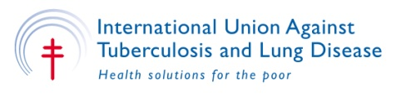

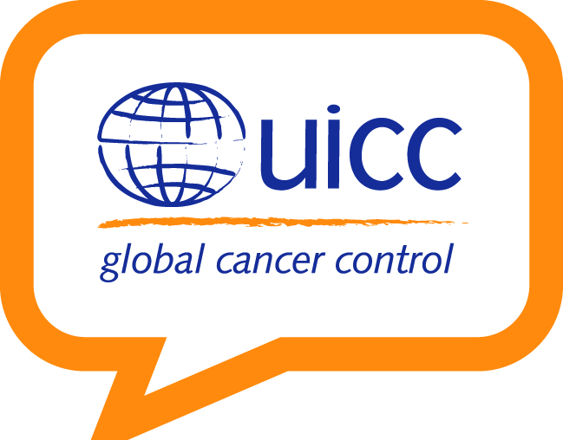
Notes to editors: The NCD Alliance unites a network of over 2,000 civil society organisations in more than 170 countries. The four founding members are the International Diabetes Federation, the Union for International Cancer Control, the World Heart Federation, and the International Union Against Tuberculosis and Lung Disease.
To interview Ann Keeling, chair of the NCD Alliance and CEO of the International Diabetes Federation, please contact Isabella Platon, Head of Communications, International Diabetes Federation. T) +32 25431625 / mobile +32 471 611 373 E) Isabella.Platon@idf.org
To interview Johanna Ralston, NCD Alliance Steering Group Member and CEO of the World Heart Federation, please contact Charanjit Jagait, Director of Communications & Advocacy, World Heart Federation. T: +41 796 253 296 E: charanjit.jagait@worldheart.org

To interview Dr Nils E Billo, NCD Alliance Steering Group Member and Executive Director of the International Union Against Tuberculosis and Lung Disease (The Union) please contact Alice Boatwright, Communications Consultant, The Union. E: aboatwright@theunion.org
To interview Cary Adams, NCD Alliance Steering Group Member and CEO of the Union for International Cancer Control, please contact Vanessa Von der Muhll, Head of Web and Communications, Tel: +41 22 809 18 11; Mobile: +41 765091901 E: vondermuhll@uicc.org

